Deploying Static Website on AWS

S3 Bucket with name 🡺 my-id-bucket

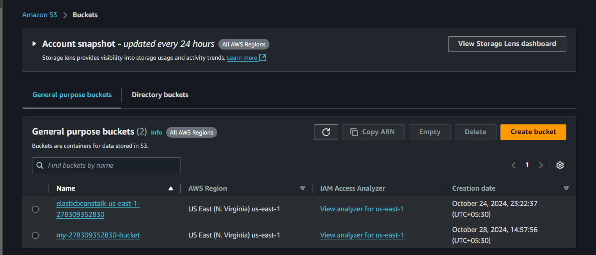

Uploaded files to the S3 Bucket

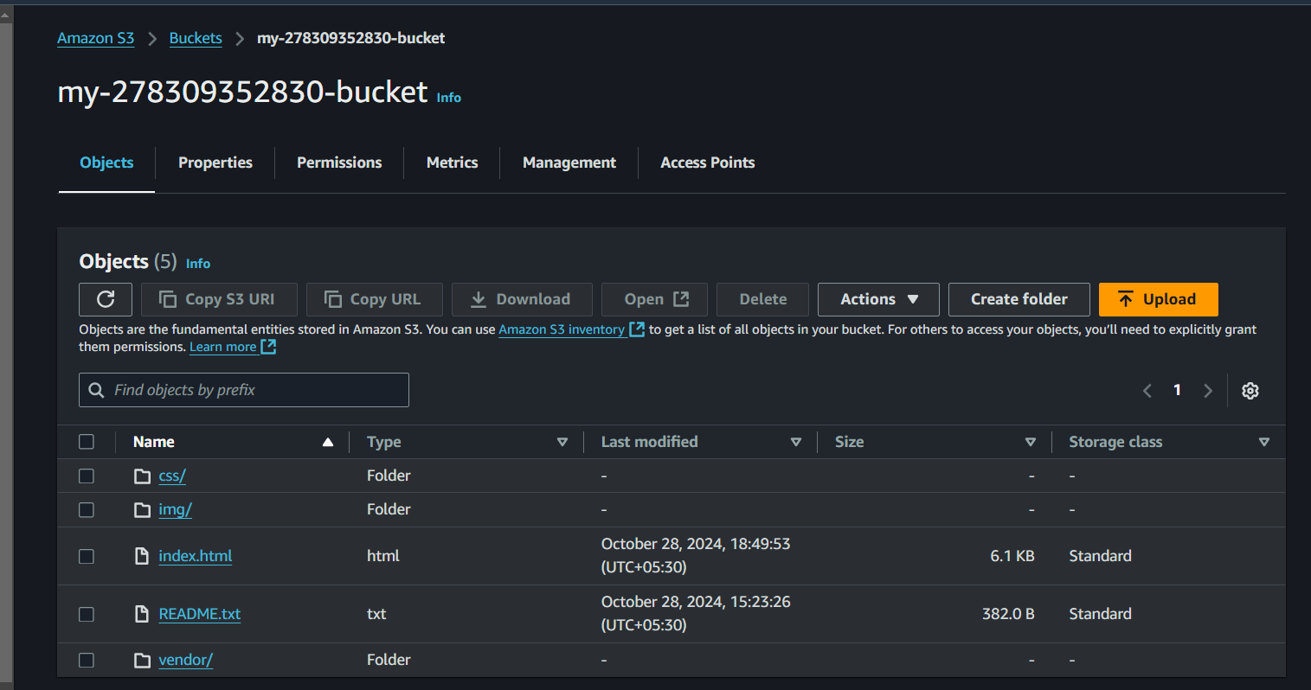

Enabled Static Website Hosting

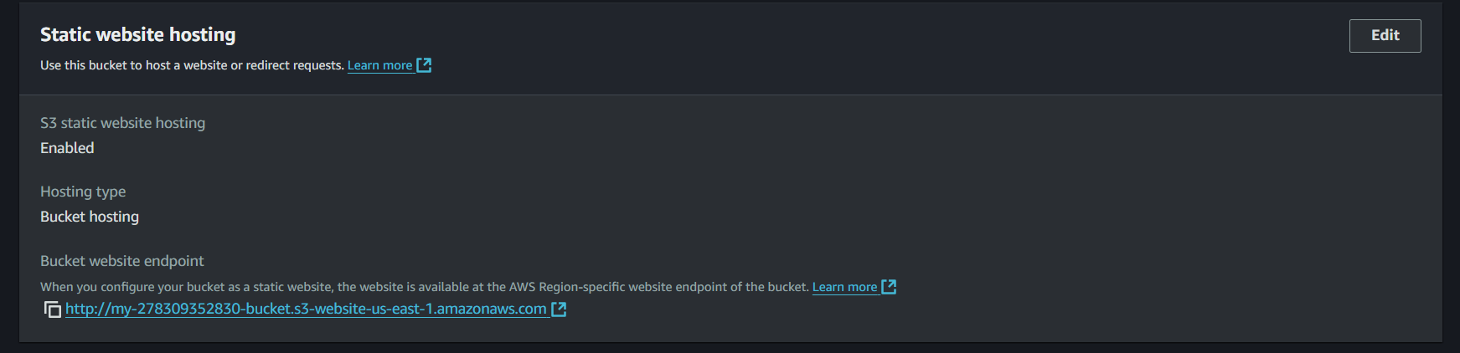

Specified Bucket Policy (making all objects public and accessible)

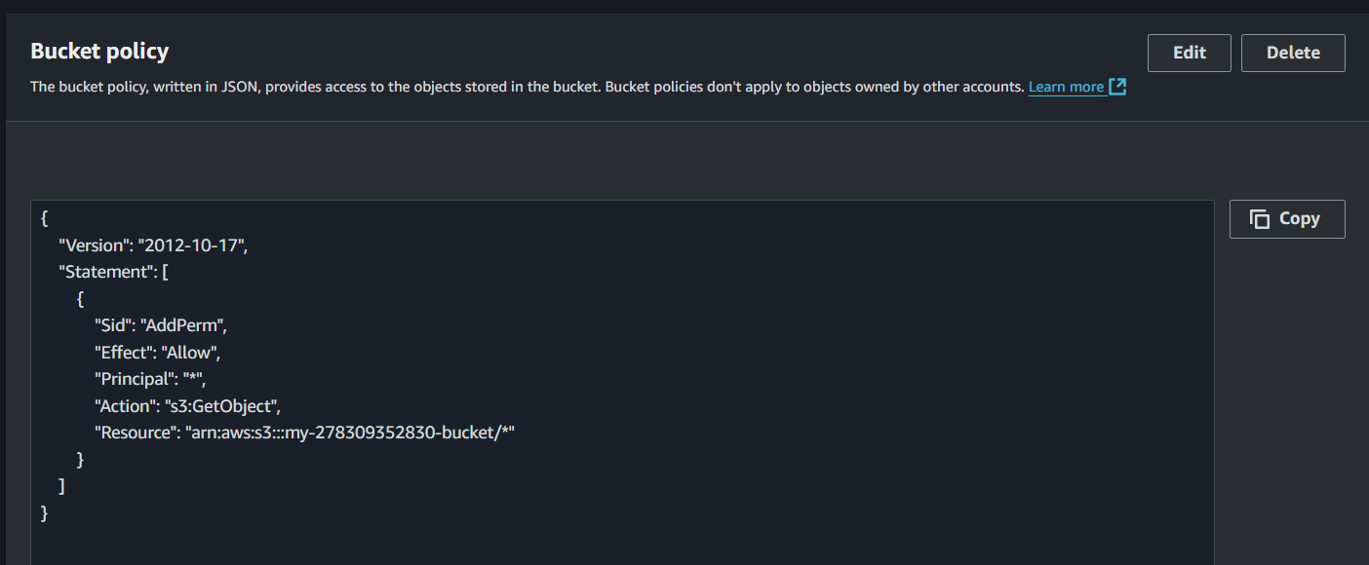

Created CloudFront Distribution to cache all files from the S3 bucket

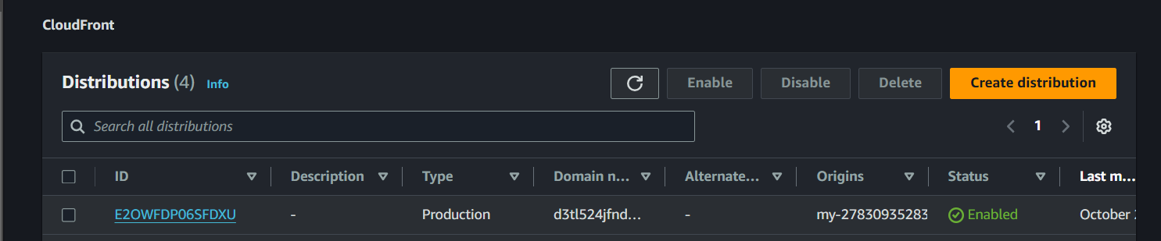

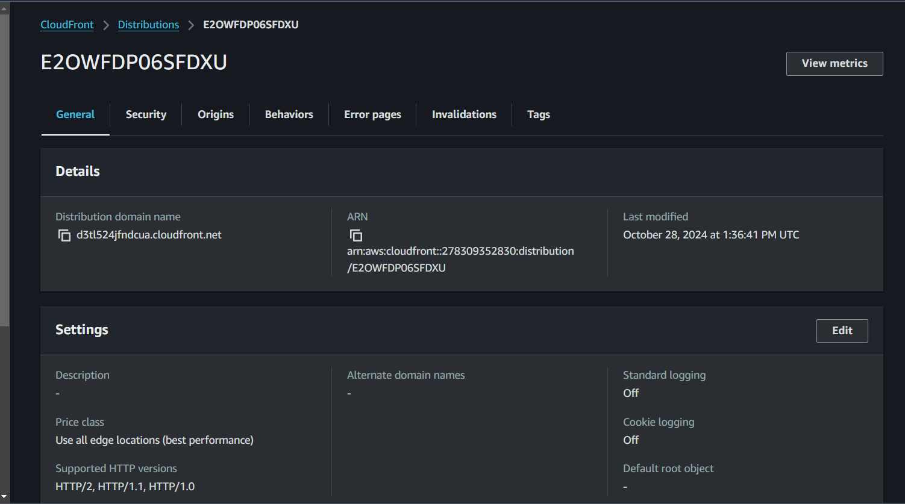

Website accessed with CloudFront domain-https://d3tl524jfndcua.cloudfront.net



Website accessed with the endpoint- http://my-278309352830-bucket.s3-website-us-east-1.amazonaws.com/



Website accessed with S3 bucket object URL - https://my-278309352830-bucket.s3.amazonaws.com/index.html

